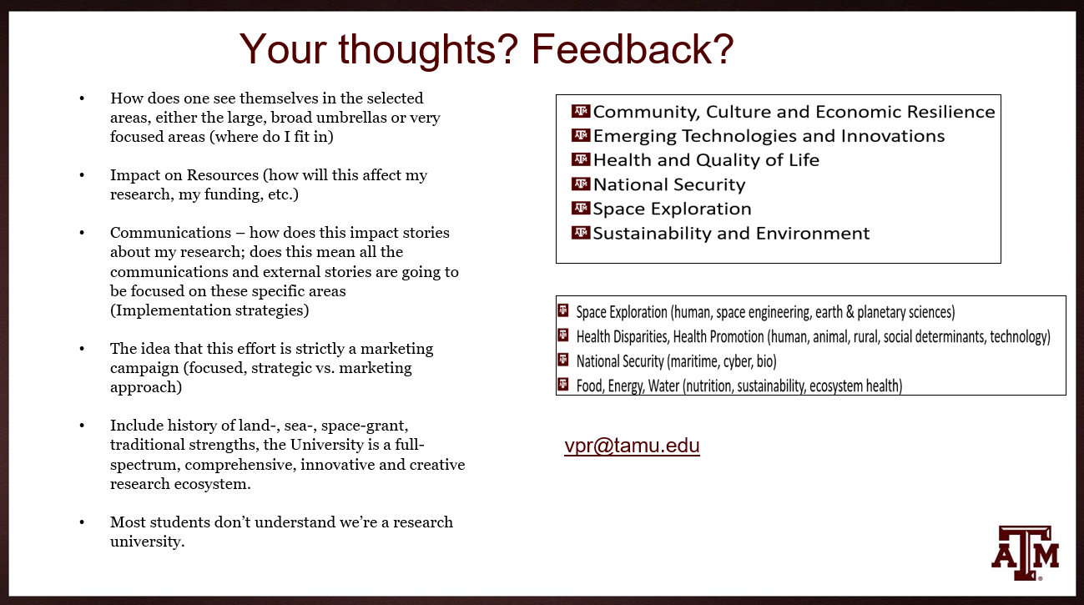
Additionally, what are your thoughts on this statement:
Texas A&M is a full spectrum comprehensive research-intensive university, with world-class faculty, professional staff, students, and postdoctoral scholars involved in foundational and translational research that promote creativity, innovation, and new knowledge, solving the world’s problems through a research ecosystem that is living, breathing, and evolving.

All Feedback requested no later than Wednesday, May 15.
Name/Email address

You may also email vpr@tamu.edu by May 15, 2024.

